Homework 3 HAN FENG 20407369 [fhanab@connect.ust.hk](mailto:fhanab@connect.ust.hk)

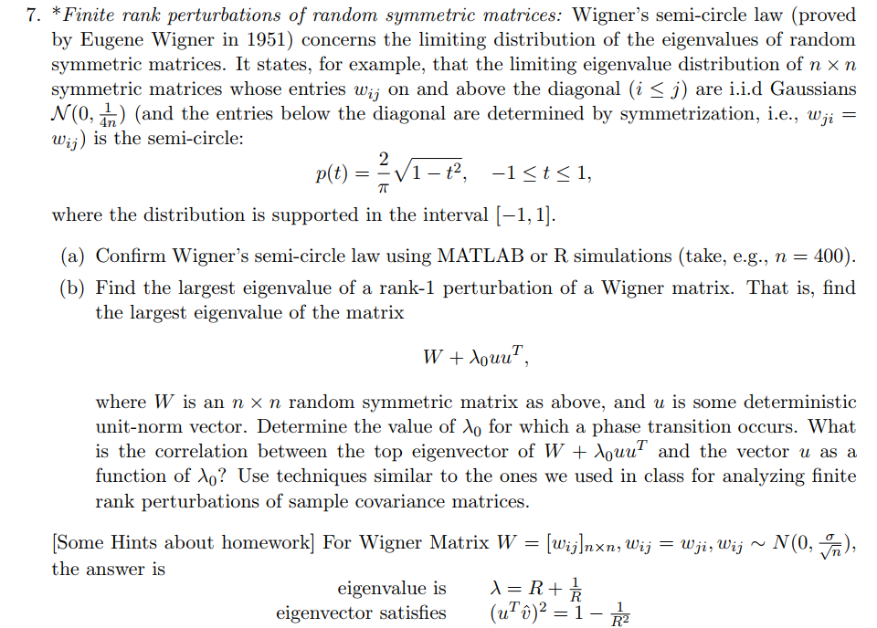

(a) Following is the histogram of eigenvalues of the random symmetric matrix as required (n=200) with the semi-circle curve.

Finite rank perturbations of random symmetric matrices:

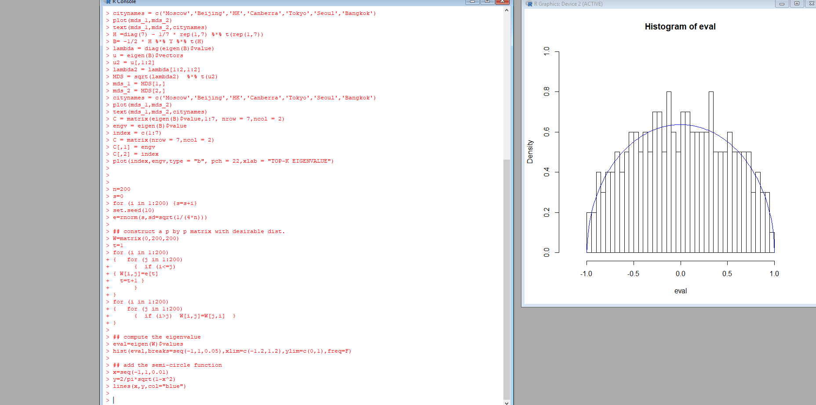

n=200

s=0

for (i in 1:200) {s=s+i}

set.seed(10)

e=rnorm(s,sd=sqrt(1/(4*n)))

## construct a p by p matrix with desirable dist.

W=matrix(0,200,200)

t=1

for (i in 1:200)

{ for (j in 1:200)

{ if (i<=j)

{ W[i,j]=e[t]

t=t+1 }

}

}

for (i in 1:200)

{ for (j in 1:200)

{ if (i>j) W[i,j]=W[j,i] }

}

## compute the eigenvalue

eval=eigen(W)$values

hist(eval,breaks=seq(-1,1,0.05),xlim=c(-1.2,1.2),ylim=c(0,1),freq=F)

## add the semi-circle function

x=seq(-1,1,0.01)

y=2/pi*sqrt(1-x^2)

lines(x,y,col="blue")